**UNIVERSITY OF ENGINEERING AND TECHNOLOGY, LAHORE**

**(NAROWAL CAMPUS)**

**­**

**NAME :**

**ABDULAHAD HUSSAIN**

**ROLL NO. :**

**549**

**SECTION:**

**A**

**SUBJECT:**

**OBJECT ORIENTED PROGRAMMING(OOP)**

**SUBMITTED TO:**

**MAM SADIA TARIQ**

**LAB MANUAL**

**LAB #03:**

**Problem No. 1:**

**Statement:**

**Array in Structure**

**Source Code:**

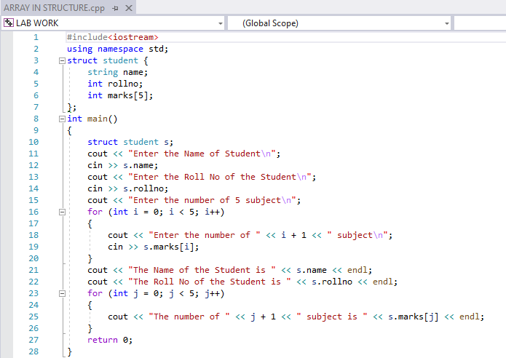

**Output:**

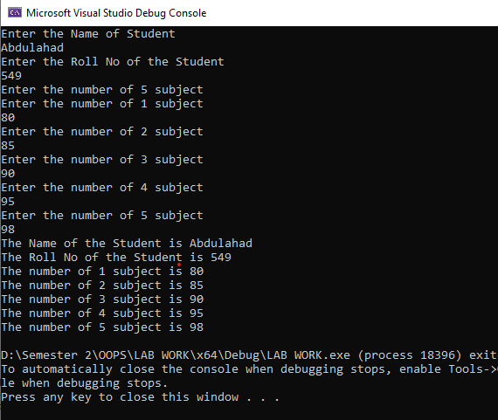

**Problem No. 2:**

**Statement:**

**Pass Structure as Parameter By Value**

**Source code:**

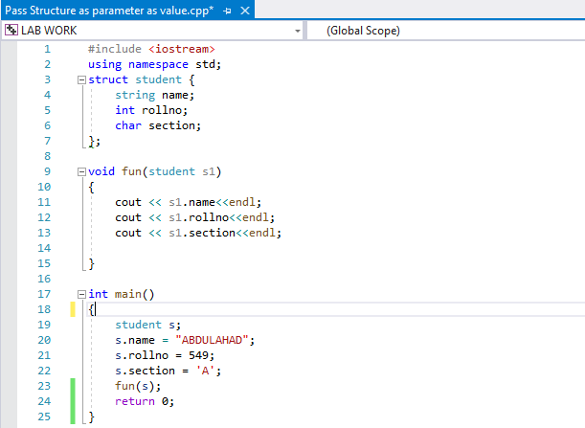

**Output:**

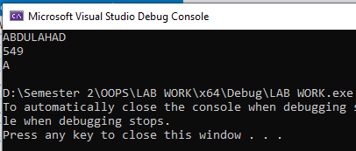

**Problem No. 3:**

**Statement:**

**Pass Structure as Parameter By reference**

**Source Code:**

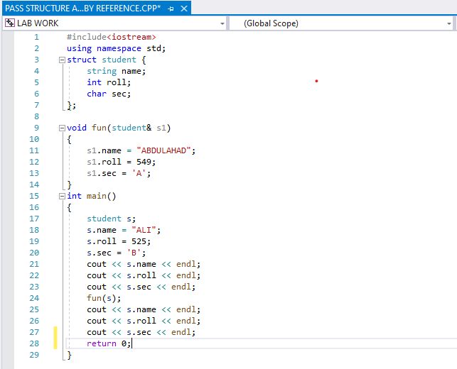

**Output:**

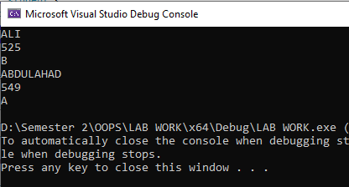

**Problem No. 4:**

**Statement:**

**Structure With Structure**

**Source Code:**

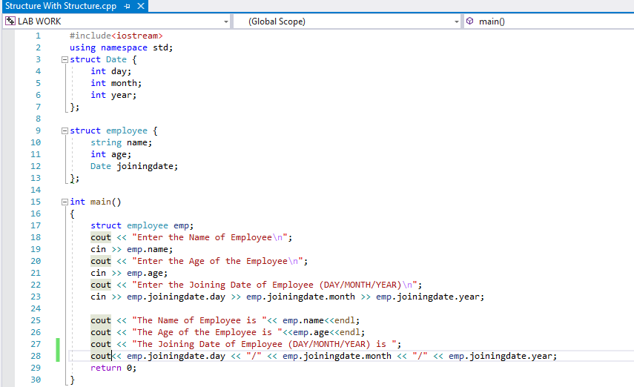

**Output:**

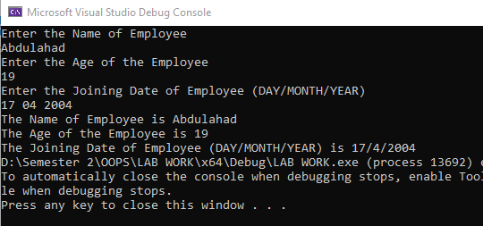

**Problem No.5:**

**Statement:**

**Using Pointer in Structure**

**Source Code:**

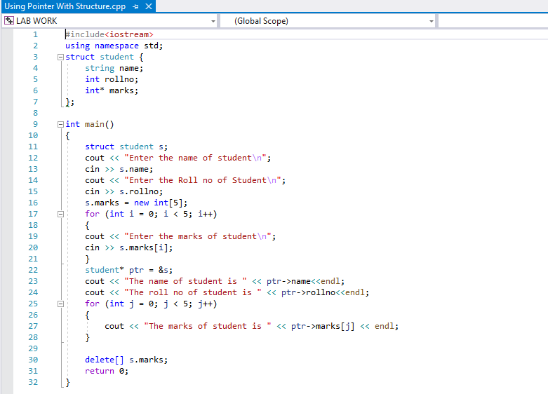

**Output:**

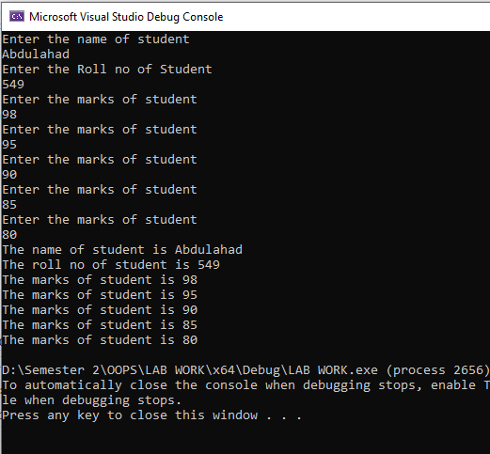

**Problem No. 6:**

**Statement:**

**Vector And Array**

**Source Code:**

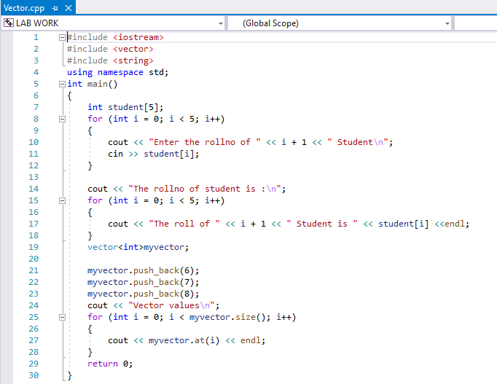

**Output:**

